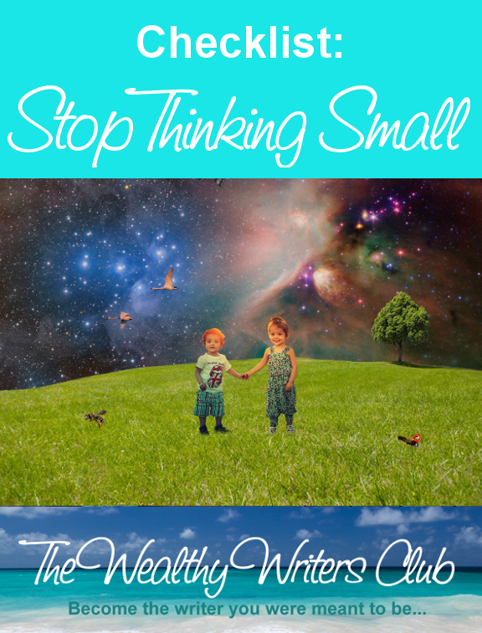

from
Suzanne Lieurance
The Wealthy Writers Club
http://www.wealthywritersclub.com

Stop Thinking Small Checklist

Use this checklist to get started with your fast track guide to stop thinking small and building the life of your dreams.
Know the Difference Between Scarcity Thinking and Abundant Thinking
- Scarcity Thinking
  - There Isn’t Enough to Go Around
  - Can’t Build Relationships Due to Lack of Trust
  - Resentful of Competition
  - You Focus on Getting By
  - You Think the Future is Gloomy
  - You Avoid Risk & Think Small
  - You Live in Fear
  - You Feel Angry & Entitled
- Abundant Thinking
  - You Know There is Not Only Enough but There is MORE
  - You Love Sharing Your Knowledge
  - You Build Valuable Relationships
  - Competitors are Welcome
  - You Want to Give MORE Value
  - You’re Optimistic About the Future
  - You Embrace Educated Risk
  - You’re Thankful & Grateful
  - You’re Confident in Your Abilities

Focus on Abundance
- You Know the World is Getting Better
- Instead of Saying I Can’t , Say Why Not
- Assess Risk but Don’t Stop Just Change Course
- You Work on Your Deficiencies
- You Embrace Your Strengths
- You Ride the Waves
- You Plan for The Future
- You Commit to The Plan
- You Don’t Wait for Perfection

Practice Gratitude
- You Say Thank You
- You Give Back
- You Always Try to Provide Extra Value
- You Show Gratitude

Write Down Your Goals
- Be Specific
- Make it Measurable
- Know That It’s Achievable (test, research)
- Ensure Your Goal is Relevant
- Set a Time Limit
- Act

Find Other Positive People Who Live in Abundance
- Network with Your Competition
- Find Other Positive People
- Build Others Confidence
- Smile
- Be Confident
- Do Your Homework
- Listen

Share the Wealth
- Teach What You Know
- Reach Out to Others
- Don’t Reach for Perfection

Get the accountability and guidance you need to succeed. Register for your Quick-Start Coaching Intensive now at http://www.quickstartfreelancewriting.com.

