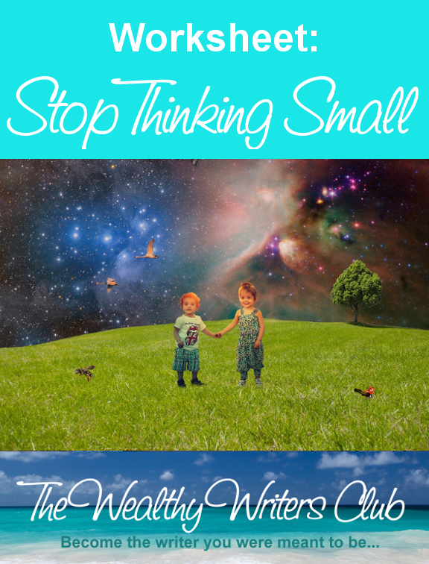

from
Suzanne Lieurance
The Wealthy Writers Club
www.wealthywritersclub.com

Fast-Track to Stop Thinking Small - Worksheet

STUDY ABUNDANCE VS. SCARCITY
Were you surprised by the fact that even drinkable water is not scarce? _______________
____________________________________________________________________________________________________________________________________________________________________________________________________________________________________
Study something you think is scarce in the world and prove it wrong. Describe it below.
____________________________________________________________________________________________________________________________________________________________________________________________________________________________________
Name your top three limiting beliefs and describe how you can turn them around.
____________________________________________________________________________________________________________________________________________________________________________________________________________________________________
PLAN YOUR FUTURE
What is your big dream for your life? __________________________________________
____________________________________________________________________________________________________________________________________________________________________________________________________________________________________

What are the first three steps you can take to get started now? ______________________
____________________________________________________________________________________________________________________________________________________________________________________________________________________________________

Plan to attend a networking event. Find at least two you can attend in the next year that will get you closer to your dream. _______________________________________________
____________________________________________________________________________________________________________________________________________________________________________________________________________________________________
TEACH SOMETHING
You can teach something in five minutes. Make a short five-minute video to teach one thing to viewers.
For example, maybe you make the perfect chicken. How can you teach someone else to do that?
____________________________________________________________________________________________________________________________________________________________________________________________________________________________________
____________________________________________________________________________________________________________________________________________________________________________________________________________________________________

DEFINE YOUR NEXT STEPS
(ex. My goal is to earn 10K in one month, what do I need to do to do that?)
Step #1: (ex. Create a product worth $197 dollars)
____________________________________________________________________________________________________________________________________________________________________________________________________________________________________
Step #2: (ex. Market the product to enough people to sell 51 of them within 30 days)
____________________________________________________________________________________________________________________________________________________________________________________________________________________________________
Step #3: (ex. Find ways to market product)
____________________________________________________________________________________________________________________________________________________________________________________________________________________________________
(keep going on another paper if needed)
DETERMINE LIMITING THOUGHTS THAT MAY ARISE TO HELP YOU AVOID THEM
Thought: ____________________________________________________________________
Change: ____________________________________________________________________
Thought: ____________________________________________________________________
Change: ____________________________________________________________________
Thought: ____________________________________________________________________
Change: ____________________________________________________________________
Thought: ____________________________________________________________________
Change: ____________________________________________________________________
Thought: ____________________________________________________________________
Change: ____________________________________________________________________

ADDITIONAL THOUGHTS
____________________________________________________________________________________________________________________________________________________________________________________________________________________________________

Get the accountability and guidance you need to succeed. Register for your Quick-Start Coaching Intensive now at http://www.quickstartfreelancewriting.com.

